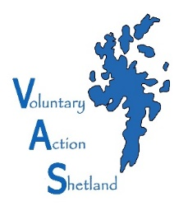

VOLUNTARY ACTION SHETLAND

Market House, 14 Market Street, Lerwick, Shetland, ZE1 0JP

: 01595743900 : vas@shetland.org : www.voluntaryactionshetland.com

A Single Point of Access for Support and Advice for the Third/Voluntary Sector

If calling please ask for: Ellen Hughson Finance Officer
Direct Dial: 01595 743903 Direct Email: ellen.hughson@shetland.org

MEMBERSHIP OF VOLUNTARY ACTION SHETLAND 2024/2025

To become a member of Voluntary Action Shetland (VAS) please complete and return the form below and VAS will invoice for payment of membership via bank transfer (preferred payment option) or cheque.

Membership is from 1st April to 31st March inclusive.

Membership Fees for 2024/2025 are as follows:- |  | Please Tick
I am applying for an Organisation Representative Membership | £35
I am applying for an Individual Membership | £15

If you have selected an Organisation Representative Membership above please indicate what type of organisation you are: | Please Tick
Charity
Company
Unincorporated Organisation
SCIO
Social Enterprise
Other: Please State

Name/Organisation Name

For Organisation Representative Membership please provide a contact name
Address
Postcode
Telephone
E-mail

Here at Voluntary Action Shetland we take your privacy seriously. We will only use your personal information to provide you with the regular information in respect of VAS services. Please tick to confirm how you would like us to contact you:
Post ☐ Email ☐ Telephone ☐

From time to time we would like to contact you to provide information about VAS services in an email newsletter format. Please tick if you agree to us providing you with a copy of our newsletter.
I agree ☐

